A
Mini Project On
PLANT DISEASE IDENTIFICATION AND PESTICIDE RECOMMENDATION USING CNN
(Submitted in partial fulfillment of the requirements for the award of Degree) BACHELOR OF TECHNOLOGY
in
COMPUTER SCIENCE AND ENGINEERING
By
G. Manisha (217R1A0525)
M.Sachin (217R1A0535)
Govardhan(217R1A0514)
Under the Guidance of
Dr. K. MAHESWARI
(Associate Professor)

DEPARTMENT OF COMPUTER SCIENCE AND ENGINEERING
CMR TECHNICAL CAMPUS
UGC AUTONOMOUS
(Accredited by NAAC, NBA, Permanently Affiliated to JNTUH, Approved by AICTE, New Delhi) Recognized Under Section 2(f) & 12(B) of the UGCAct .1956,Kandlakoya (V), Medchal Road,Hyderabad-501401.
2021-25

DEPARTMENT OF COMPUTER SCIENCE AND ENGINEERING
CERTIFICATE
This is to certify that the project entitled “PLANT DISEASE IDENTIFICATION AND PESTICIDE RECOMMENDATION USING CNN” being submitted G.Manisha (217R1A0525),M. Sachin (217R1A0535) &B. Govardhan(217R1A0514) in partial fulfillment of the requirements for the award of the degree of B.Tech in Computer Science and Engineering to the Jawaharlal Nehru Technological University Hyderabad, is a record of bonafide work carried out by him/her under our guidance and supervision during the year 2024-25.

The results embodied in this thesis have not been submitted to any other University or Institute for the award of any degree or diploma.

Dr.K.Maheswari Dr. A. Raji Reddy Associate Professor DIRECTOR
INTERNAL GUIDE

Dr. N. Bhaskar EXTERNAL EXAMINER
HOD

Submitted for viva voice Examination held on

ACKNOWLEGDEMENT
Apart from the efforts of us, the success of any project depends largely on the encouragement and guidelines of many others. We take this opportunity to express our gratitude to the people who have been instrumental in the successful completion of this project. We take this opportunity to express my profound gratitude and deep regard to my guide
Dr. K.Maheswari, Associate Professor for her exemplary guidance, monitoring and constant encouragement throughout the project work. The blessing, help and guidance given by her shall carry us a long way in the journey of life on which we are about to embark. We also take this opportunity to express a deep sense of gratitude to Project Review Committee (PRC) Coordinators: Dr. K.Maheswari , Dr S.Suma ,Mr. J.Narasimha Rao, Mrs. K.Shilpa, Mr. K.Ranjith Reddy for their cordial support, valuable information and guidance, which helped us in completing this task through various stages.
We are also thankful to Dr. N. Bhaskar, Head, Department of Computer Science and Engineering for providing encouragement and support for completing this project successfully.
We are obliged to Dr. A. Raji Reddy, Director for being cooperative throughout the course of this project. We would like to express our sincere gratitude to Sri. Ch. Gopal Reddy, Chairman for providing excellent infrastructure and a nice atmosphere throughout the course of this project.
The guidance and support received from all the members of CMR Technical Campus who contributed to the completion of the project. We are grateful for their constant support and help.
Finally, we would like to take this opportunity to thank our family for their constant encouragement, without which this assignment would not be completed. We sincerely acknowledge and thank all those who gave support directly and indirectly in the completion of this project.
G. MANISHA(217R1A0525)
M. SACHIN(217R1A0535)
B.GOVARDHAN(217R1A0514)
ABSTRACT
Plant diseases pose a significant threat to agriculture, particularly in India, where farmers lose 35% of their crops to pests and diseases. Reckless pesticide use worsens the problem, with toxic chemicals impacting health and the environment. To address this, we developed a smartphone app that enables farmers to take pictures of diseased plants for AI-based analysis and real-time disease prediction. The app uses convolutional neural networks (CNNs) trained on large datasets of plant images, achieving over 95% detection accuracy. Geo-tagged images and micro-climatic data help generate infection density maps and unfold predictions. Farmers can also connect with local experts via a web interface for personalized advice. This cloud-based platform offers an eco-friendly, scalable solution for disease management.

LIST OF FIGURES

FIGURE NO | FIGURE NAME | PAGE NO
Figure 3.1 | System Architecture | 10
Figure 3.2 | Use case diagram | 12
Figure 3.3 | Class diagram | 13
Figure 3.4 | Sequence diagram | 14
Figure 3.5 | Activity diagram | 15

RESULTS AND DISCUSSIONS
FIGURE NO. | FIGURE NAME | PAGE NO.
Figure 5.1 | Signup screen | 23
Figure 5.2 | User login page | 24
Figure 5.3 | Upload image screen | 24
Figure 5.4 | Upload image | 25
Figure 5.5 | Result | 27

TABLE OF CONTENTS

ABSTRACT |  |  |  |  |  |  | i
LIST OF FIGURES |  |  |  |  |  |  | ii
RESULTS AND DISCUSSIONS |  |  |  |  |  |  | iii
1. |  | INTRODUCTION |  |  |  |  | 1
 |  | 1.1 |  | PROJECT SCOPE |  |  | 2
 |  | 1.2 |  | PROJECT PURPOSE |  |  | 2
 |  | 1.3 |  | PROJECT FEATURES |  |  | 2
2. |  | SYSTEM ANALYSIS |  |  |  |  | 4
 |  | 2.1 |  | PROBLEM DEFINITION |  |  | 4
 |  | 2.2 |  | EXISTING SYSTEM |  |  | 5
 |  |  |  | 2.2.1 | LIMITATIONS OF THE EXISTING SYSTEM |  | 5
 |  | 2.3 |  | PROPOSED SYSTEM |  |  | 5
 |  |  |  | 2.3.1 | ADVANTAGES OF PROPOSED SYSTEM |  | 5
 |  | 2.4 |  | FEASIBILITY STUDY |  |  | 6
 |  |  |  | 2.4.1 | ECONOMIC FESIBILITY |  | 6
 |  |  |  | 2.4.2 | TECHNICAL FEASIBILITY |  | 7
 |  |  |  | 2.4.3 | BEHAVIOURAL FEASIBILITY |  | 7
 |  | 2.5 |  | HARDWARE & SOFTWARE REQUIREMENTS |  |  | 8
 |  |  |  | 2.5.1 | HARDWARE REQUIREMENTS |  | 8
 |  |  |  | 2.5.2 | SOFTWARE REQUIREMENTS |  | 8
3. |  | ARCHITECTURE |  |  |  |  | 9
 |  | 3.1 |  | PROJECT ARCHITECTURE |  |  | 10
 |  | 3.2 |  | DESCRIPTION |  |  | 11
 |  | 3.3 |  | USECASE DIAGRAM |  |  | 12
 |  | 3.4 |  | CLASS DIAGRAM |  |  | 13
 |  | 3.5 |  | SEQUENCE DIAGRAM |  |  | 14
 |  | 3.6 |  | ACTIVITY DIAGRAM |  |  | 15
4. |  | IMPLEMENTATION |  |  |  |  | 16
 |  | 4.1 |  | SAMPLE CODE |  |  | 17
5. |  | RESULTS AND DISCUSSIONS |  |  |  |  | 21
6. |  | TESTING |  |  |  |  | 26
 | 6.1 |  | INTRODUCTION TO TESTING |  |  |  | 27
 | 6.2 |  | TYPES OF TESTING |  |  |  | 27
 |  |  | 6.2.1 |  |  | UNIT TESTING | 27
 |  |  | 6.2.2 |  |  | INTEGRATION TESTING | 27
 |  |  | 6.2.3 |  |  | FUNCTIONAL TESTING | 28
 | 6.3 |  | TEST CASES |  |  |  | 28
 |  |  | 6.3.1 |  |  | UPLOADING IMAGES | 28
 |  |  | 6.3.2 |  |  | CLASSIFICATION | 29
7. | CONCLUSION & FUTURE SCOPE |  |  |  |  |  | 30
 | 7.1 |  | PROJECT CONCLUSION |  |  |  | 31
 | 7.2 |  | FUTURE SCOPE |  |  |  | 31
8. | BIBLIOGRAPH |  |  |  |  |  | 33
 | 8.1 |  | REFERENCES |  |  |  | 34

1.INTRODUCTION

- INTRODUCTION

1.1 PROJECT SCOPE

The project "Plant Disease Identification and Pesticides Recommendation using CNN" aims to develop an AI-driven system that accurately detects plant diseases from images and recommends optimal pesticides. Using Convolutional Neural Networks (CNNs) for disease classification, the system enhances agricultural productivity by providing real-time, automated solutions for disease diagnosis. The project can be expanded to multiple crops and integrated with IoT sensors or mobile devices, enabling farmers to make informed, eco-friendly decisions, reducing crop loss and minimizing pesticide misuse.

1.2 PROJECT PURPOSE
The purpose of the "Plant Disease Identification and Pesticides Recommendation using CNN" project is to leverage deep learning techniques to automatically identify plant diseases from images and suggest appropriate pesticide treatments. This project aims to assist farmers in making timely, accurate decisions to prevent crop loss, reduce the misuse of pesticides, and enhance overall agricultural productivity. By using CNN models, the system offers a user-friendly, real-time solution for disease diagnosis, optimizing pesticide use while promoting sustainable farming practices.

1.3 PROJECT FEATURES
The project features advanced image-based disease detection using Convolutional Neural Networks , offering accurate identification of a wide range of plant diseases. It provides tailored pesticide recommendations based on the detected disease, crop type, and severity, ensuring precise and effective treatment. The system supports real-time processing, enabling farmers to receive instant diagnoses and timely interventions. It is designed to handle multiple crop types, making it versatile for various agricultural applications.

2 . SYSTEM ANALYSIS

- SYSTEM ANALYSIS

The system analysis of the "Plant Disease Identification and Pesticides Recommendation using CNN" involves several critical components. First, the system collects plant images, which serve as input data for disease detection. A Convolutional Neural Network (CNN) is trained on a dataset of diseased and healthy plant images to classify and identify specific plant diseases. The system then cross-references the identified disease with a database of pesticides to recommend the most suitable treatment. The analysis includes understanding data preprocessing techniques, model architecture, training parameters, and accuracy evaluation. The system also considers user needs, ensuring ease of use for farmers through mobile integration and real-time diagnosis, even in remote areas.

  - PROBLEM DEFINITION

The problem addressed by the "Plant Disease Identification and Pesticides Recommendation using CNN" project is the challenge of timely and accurate diagnosis of plant diseases, which is crucial for preventing crop loss and ensuring agricultural productivity. Farmers, particularly in rural and developing areas, often lack the expertise or resources to identify diseases early, leading to overuse or misuse of pesticides. This not only affects crop health but also harms the environment and increases costs. Traditional methods of disease identification, which rely on expert consultation or manual inspection, are time-consuming, expensive, and prone to error.
The project aims to solve this problem by developing an AI-based system that uses Convolutional Neural Networks (CNNs) to automatically identify diseases from plant images. It further provides targeted pesticide recommendations, ensuring precise treatment and reducing chemical overuse. This system offers a real-time, accessible solution for farmers, enabling them to act quickly and improve crop management with minimal expertise.

2.2 EXISTING SYSTEM
Nearly one-third of India's harvest goes to waste due to pests and diseases. Careless use of pesticides, many of which are toxic and biomagnified, poses an additional serious threat to human health. Possible solutions to these problems include early disease detection, crop monitoring, and individualised therapies. In most cases, experts in agriculture can identify a disease only by observing its symptoms. However, farmers have a hard time getting in touch with professionals.
2.2.1 LIMITATIONS OF EXISTING SYSTEM
- Time-consuming and labor-intensive
- Prone to human error
- Difficult to diagnose diseases at early stages or in large-scale fields.
- Lack of robustness and accuracy in automated systems
To avoid all these limitations and make the working more accurately the system needs to be implemented efficiently.
2.3 PROPOSED SYSTEM
The proposed system for "Plant Disease Identification and Pesticides Recommendation using CNN" involves a deep learning-based platform that uses Convolutional Neural Networks (CNNs) to analyze plant images and accurately identify diseases. Once a disease is detected, the system recommends appropriate pesticides based on the specific disease and crop type. The system can be deployed on mobile or edge devices, providing real-time, on-field diagnostics and treatment advice. It supports multiple crops and diseases, offering farmers an efficient, user-friendly tool for disease management, reducing pesticide misuse, and improving agricultural productivity.
2.3.1 ADVANTAGES OF PROPOSED SYSTEM
- Higher accuracy in disease prediction

- Faster and more efficient than manual methods.
- Scalable to large-scale agricultural fields.
- User-friendly interfaces and mobile applications for easy deployment and usage.
2.4 FEASIBILITY STUDY
The feasibility study examines technical, economic, and operational viability. Technically, CNNs are proven for image recognition tasks, making disease identification achievable. Economically, the system reduces costs by minimizing pesticide misuse and expert consultation. Operationally, mobile integration ensures easy use by farmers, even in remote areas. The system's scalability across multiple crops and diseases further enhances its practicality and broad agricultural impact
- Technical Viability
- Economic Benefits
- Operational Ease
2.4.1 ECONOMIC FEASIBILITY
Plant disease identification using Convolutional Neural Networks (CNN) enhances agricultural productivity by enabling early detection and precise diagnosis of plant diseases. This approach uses image data to train CNN models, which can classify diseases accurately. By automating the diagnosis, farmers save time and reduce crop losses, improving economic feasibility. Additionally, integrating pesticide recommendations with CNN models ensures targeted pest control, optimizing pesticide use and reducing costs. Economic benefits include reduced labor, increased yield, and minimal environmental impact from excessive pesticide use. CNN-based systems are scalable and adaptable, making them suitable for large and small-scale farming, driving sustainable agriculture.
- Early and accurate disease detection with CNN.
- Targeted pesticide recommendations.
- Reduced crop loss and labor costs
.
- Optimized pesticide usage
- Scalable for diverse farming operations.
2.4.2 TECHNICAL FEASIBILITY
Using CNN for plant disease identification and pesticide recommendation is technically feasible due to advancements in deep learning and image processing. CNN models can be trained on large datasets of plant images, enabling precise disease classification. With high computational power, these models efficiently handle complex image features. Integration of IoT devices like drones or smartphones for real-time data collection enhances system efficiency. However, building accurate models requires sufficient labeled data, computational resources, and continuous updates to adapt to new disease variants.
2.4.3 BEHAVIOURAL FEASIBILITY
The behavioral feasibility of using CNN for plant disease identification and pesticide recommendation depends on farmers' willingness to adopt new technology. While CNN systems offer accurate diagnostics and cost-saving pesticide use, farmers may need training to understand and trust these tools. Younger, tech-savvy farmers may adopt it more readily, while older generations might resist. Successful adoption hinges on education, user-friendly interfaces, and demonstrations of the technology’s practical benefits in farming.
2.5 HARDWARE AND SOFTWARE REQUIREMENTS
2.5.1 HARDWARE REQUIREMENTS
Hardware interfaces specifies the logical characteristics of each interface between the software product and the hardware components of the system. Thefollowing are some hardware requirements.
- System : Windows
- Processor : intel core i3 or above
- Hard Disk : 512 GB
- RAM : 8 GB
2.5.2 SOFTWARE REQUIREMENTS
Software Requirements specifies the logical characteristics of each interface and software components of the system. The following are some software requirements,
- Operating System : Windows
- Coding Language : Python
- Deep Leaning Libraries : (TensorFLow,Keras)
- Image Processing Libraries : OpenCV

3.ARCHITECTURE

3 ARCHITECTURE

3.1 PROJECT ARCHITECTURE

This project architecture shows the procedure followed for pesticide recommendation machine learning, starting from input to final prediction.
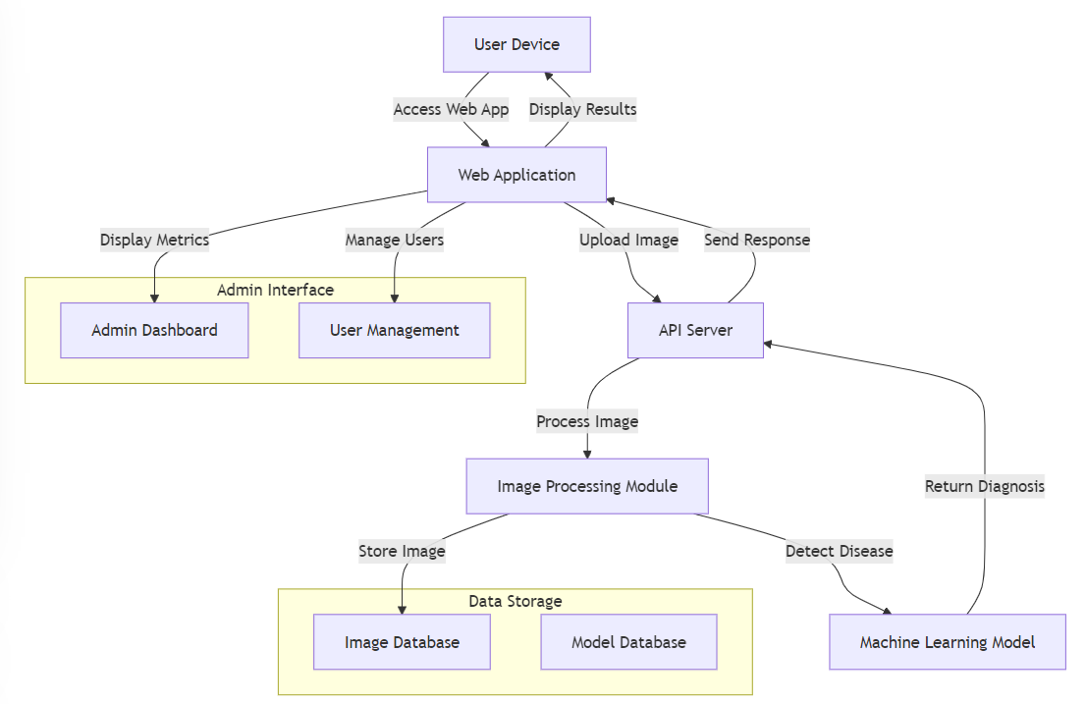

3.2 DESCRIPTION
- The Plant Doctor Interface
User Launches: The process begins when the user opens the application
User Takes Picture & Uploads: The user captures an image of the plant and upload

- Disease Classifier

Auto Classify Image: The uploaded image is processed using a trained CNN model to automatically identify the disease type.
Classification Accuracy Check: The system checks if the disease classification accuracy exceeds a set threshold.
Store Image & Metadata: Both the image and relevant metadata (e.g., disease type, location) are stored in the database
Generate Disease Density Maps: Based on the disease type and location, the system creates disease density maps to show the spread.

- Deep CNN Trainer

Training Database: The system stores images and metadata in the training database.
Retrain CNN Model: The CNN model is periodically retrained with new images to improve its classification accuracy and robustness.

  - USE CASE DIAGRAM
In the use case diagram we have basically two actors who are the user(Farmer) and the administrator. The user has the rights to login, access to resources and to view thecrime details. Whereas the administrator has the login, access to resources of the users and also the right to update and remove the crime details, and he can also view the user files.

Figure 3.2
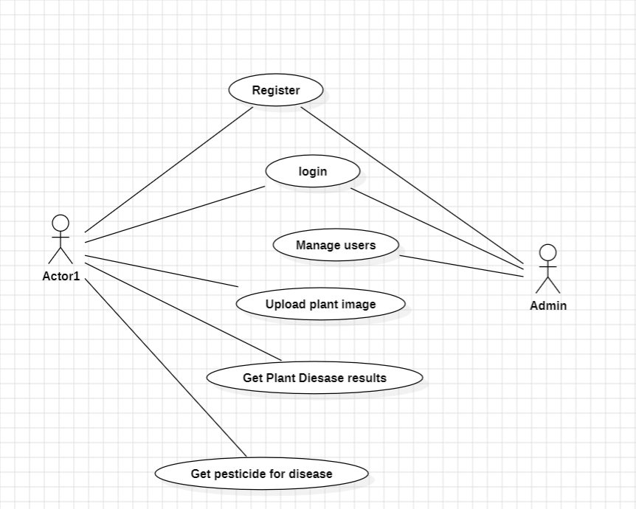

  - CLASS DIAGRAM

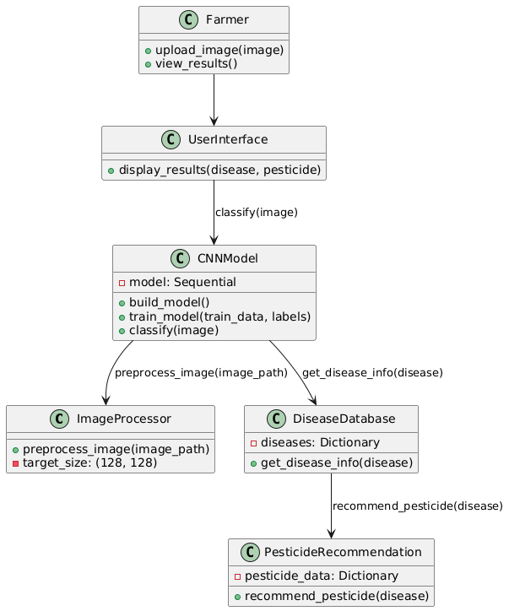

  - SEQUENCE DIAGRAM
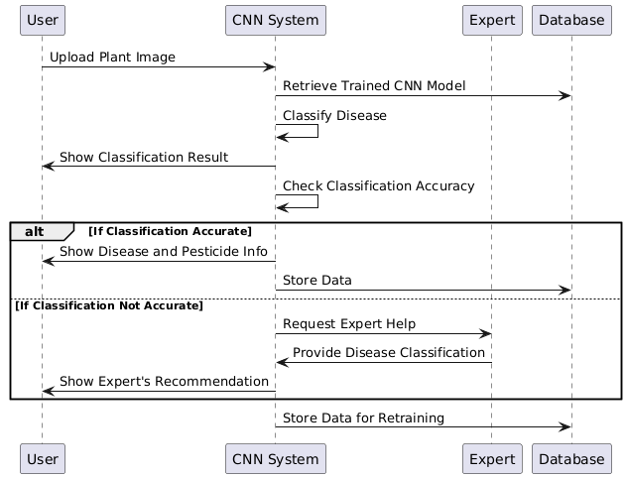
Figure 3.3

  - ACTIVITY DIAGRAM 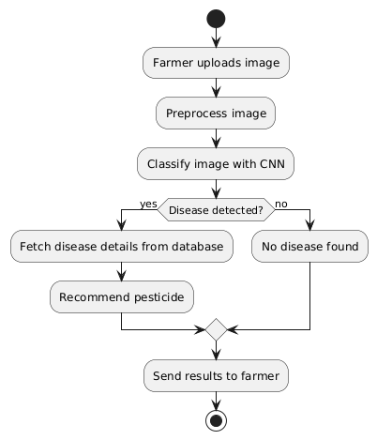
Figure 3.5

4. IMPLEMENTATION

4.1 SAMPLE CODE
import numpy as np
import os
from keras.models import model_from_json
from keras.utils.np_utils import to_categorical
import cv2
from sklearn.model_selection import train_test_split
from keras.layers import Input
from keras.models import Model
from keras.layers import Conv2D, MaxPooling2D
from keras.layers import Dense, Dropout, Activation, Flatten
from keras.layers import Convolution2D
from keras.models import Sequential
import keras
plants = ['Pepper__bell___Bacterial_spot', 'Pepper__bell___healthy', 'Potato___Early_blight', 'Potato___healthy', 'Potato___Late_blight', 'Tomato_Bacterial_spot','Tomato_Early_blight', 'Tomato_healthy', 'Tomato_Late_blight', 'Tomato_Leaf_Mold', 'Tomato_Septoria_leaf_spot','Tomato_Spider_mites_Two_spotted_spider_mite', 'Tomato__Target_Spot', 'Tomato__Tomato_mosaic_virus', 'Tomato__Tomato_YellowLeaf__Curl_Virus']
X = []
Y = []
for i in range(len(plants)):
for root, dirs, directory in os.walk('PlantVillage/'+plants[i]):
for j in range(len(directory)):
img = cv2.imread('PlantVillage/'+plants[i]+"/"+directory[j])
img = cv2.resize(img, (64,64))
im2arr = np.array(img)
im2arr = im2arr.reshape(64,64,3)
X.append(im2arr)
Y.append(i)
print('PlantVillage/'+plants[i]+"/"+directory[j])
np.save("model/myimg_data.txt",X)
np.save("model/myimg_label.txt",Y)
X = np.load("model/myimg_data.txt.npy")
Y = np.load("model/myimg_label.txt.npy")
X = np.asarray(X)
Y = np.asarray(Y)
print(X.shape)
Y = to_categorical(Y)
print(Y.shape)
img = X[20].reshape(64,64,3)
cv2.imshow('ff',cv2.resize(img,(250,250)))
cv2.waitKey(0)
print("shape == "+str(X.shape))
print("shape == "+str(Y.shape))
print(Y)
X = X.astype('float32')
X = X/255
indices = np.arange(X.shape[0])
np.random.shuffle(indices)
X = X[indices]
Y = Y[indices]
classifier = Sequential() #alexnet transfer learning code here
classifier.add(Convolution2D(32, 3, 3, input_shape = (64, 64, 3), activation = 'relu'))
classifier.add(MaxPooling2D(pool_size = (2, 2)))
classifier.add(Convolution2D(32, 3, 3, activation = 'relu'))
classifier.add(MaxPooling2D(pool_size = (2, 2)))
classifier.add(Flatten())
classifier.add(Dense(output_dim = 128, activation = 'relu'))
classifier.add(Dense(output_dim = 15, activation = 'softmax'))
classifier.compile(optimizer ='adam',loss='categorical_crossentropy', metrics = ['accuracy'])
print(classifier.summary())
classifier. Fit(X, Y, batch_size=16,epochs=10,validation_split=0.2,shuffle=True, verbose=2)
classifier.save_weights('model/model_weights.h5')
model_json = classifier.to_json()
with open("model/model.json", "w") as json_file:json_file.write(model_jsoN
with open('model/model.json', "r") as json_file: loaded_model_json = json_file.read()
loaded_model = model_from_json(loaded_model_json)
loaded_model.load_weights("model/model_weights.h5")
loaded_model._make_predict_function()
print(loaded_model.summary())
img = cv2.imread('download.jpg')
img = cv2.resize(img, (64,64))
im2arr = np.array(img)
im2arr = im2arr.reshape(1,64,64,3)
X = np.asarray(im2arr)
X = X.astype('float32')
X = X/255
preds = loaded_model.predict(X)
print(str(preds)+" "+str(np.argmax(preds)))
predict = np.argmax(preds)
print(plants[predict])
img = im2arr.reshape(64,64,3)
cv2.imshow(plants[predict],cv2.resize(img,(250,250)))
cv2.waitKey(0)

5. RESULTS AND DISCUSSIONS

5.1 SIGNUP SCREEN

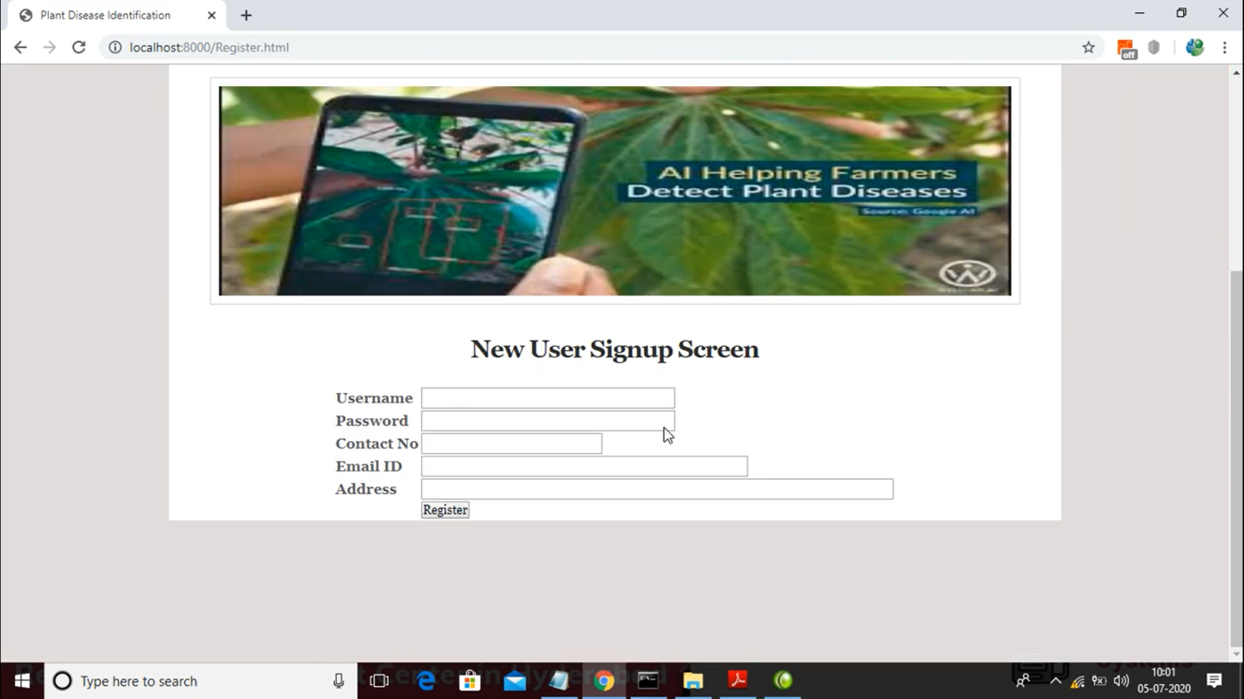

Figure 5.1 Signup screen user need to enter credentials

The image shows a registration page for a web application named "Plant Disease Identification and Pesticide Recommendation using CNN." The page features a "New User Signup Screen" where users can fill out a form to register. The form includes fields for entering a username, password, contact number, email ID, and address. Above the form, there is a promotional banner image that illustrates the use of AI in helping farmers detect plant diseases, with a smartphone capturing a plant image as part of the process. The page has a simple design, indicating that the application aims to facilitate user registration for accessing its plant disease detection services.

5.2 USER LOGIN PAGE

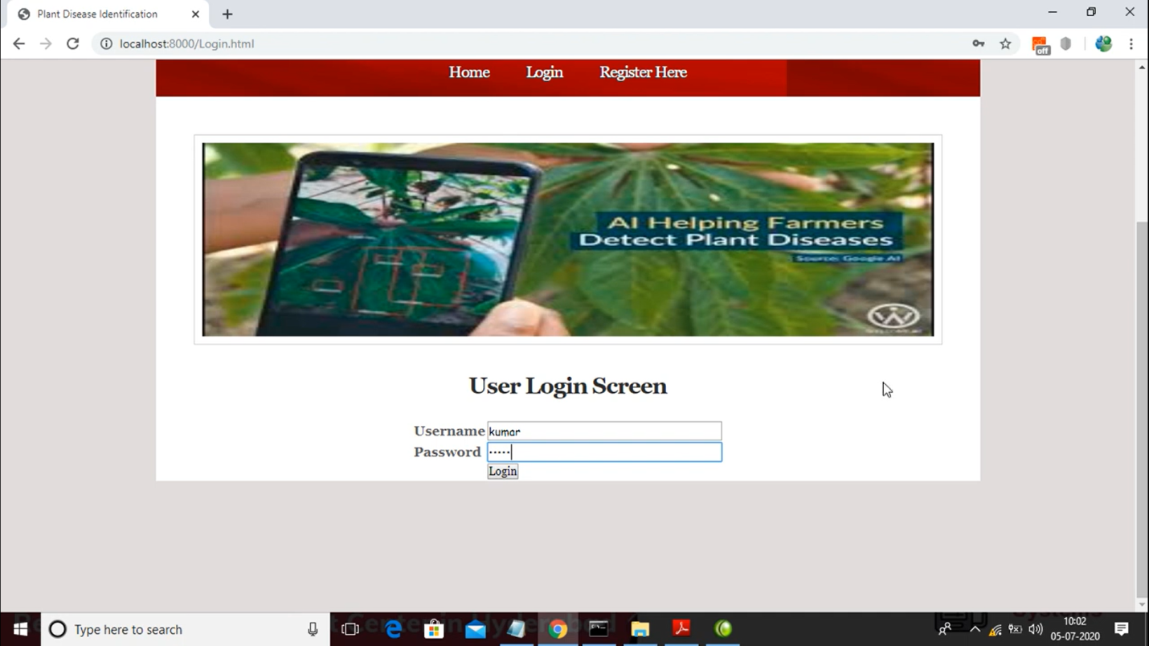

Figure 5.2 User Login Page

The image shows a login page for a system related to “Plant Disease Identification and Pesticide Recommendtion using CNN”. At the top of the page, there is a navigation menu with links for "Home," "Login," and "Register Here." Below the banner, the main content is a "User Login Screen" with input fields for a username and password. In the image, the username "kumar" is typed into the username field, and the password field is filled with obscured characters. There is a "Login" button below the fields. The system appears to be a web-based platform, as seen by the URL in the browser’s address bar, which points to "localhost:8000/Login.html," indicating that the webpage is hosted locally on the user's machine.This page allows to login and further can enter the images for processing

5.3 UPLOAD IMAGE SCREEN
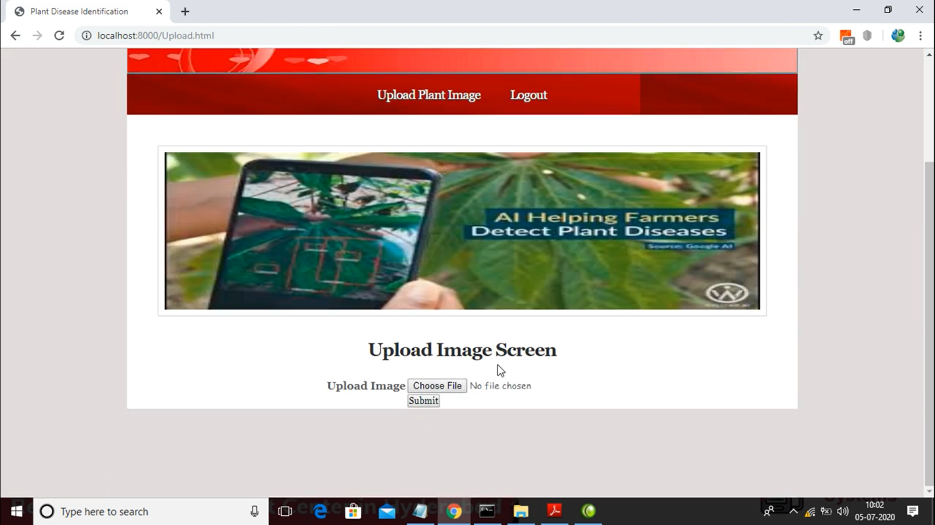

Figure 5.3 Upload Image Screen
The image displays an "Upload Image Screen" from a web-based platform related to Plant Disease Identification and Pesticide Recommendation using CNN . The navigation bar at the top offers options for "Upload Plant Image" and "Logout." Below the banner, there is a file upload section where users can choose a file (image of a plant) and submit it, likely for analysis or disease identification.The Disease affected plant images are uploaded for processing or evaluating the disease

5.4 UPLOAD IMAGE

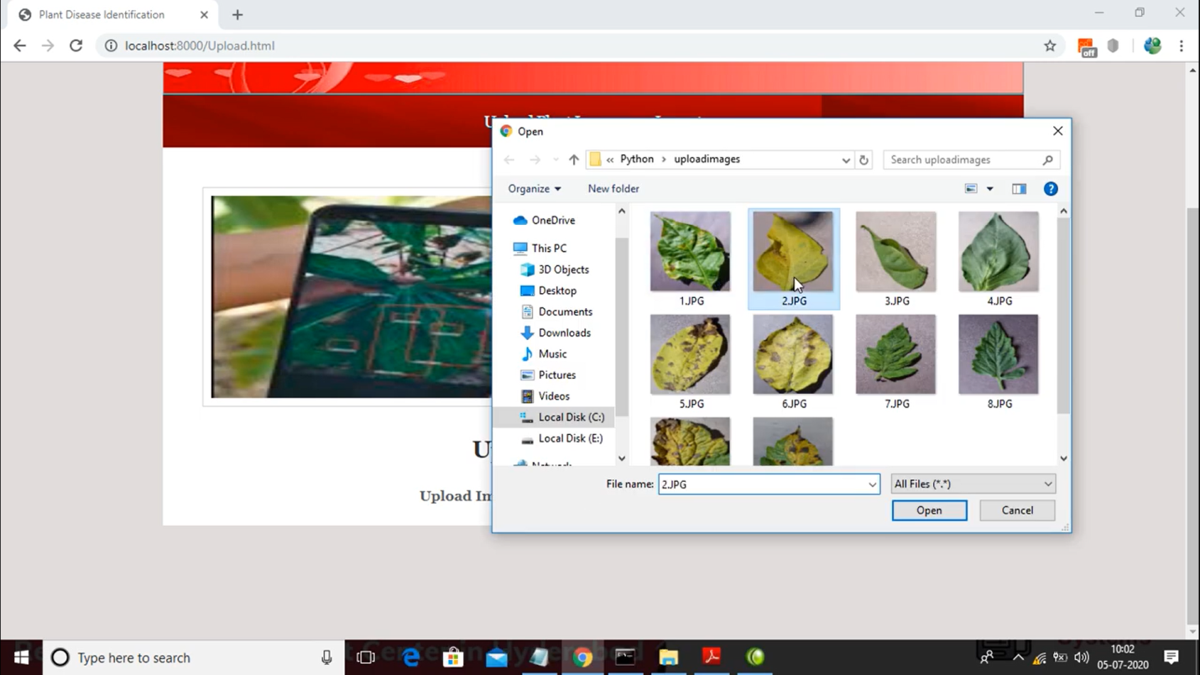

Figure 5.4 Upload Image

The image shows the process of selecting a file for upload on a plant disease identification platform. In the foreground, a file explorer window is open, displaying a folder named "uploadimages" with several images of plant leaves, each showing various symptoms of disease. The user has highlighted an image named "2.JPG," which appears to show a leaf with visible yellowing, possibly indicating a plant disease. This is part of an ongoing interaction with the "Upload Image Screen," where users can choose and submit plant images for analysis.

5.5 RESULT

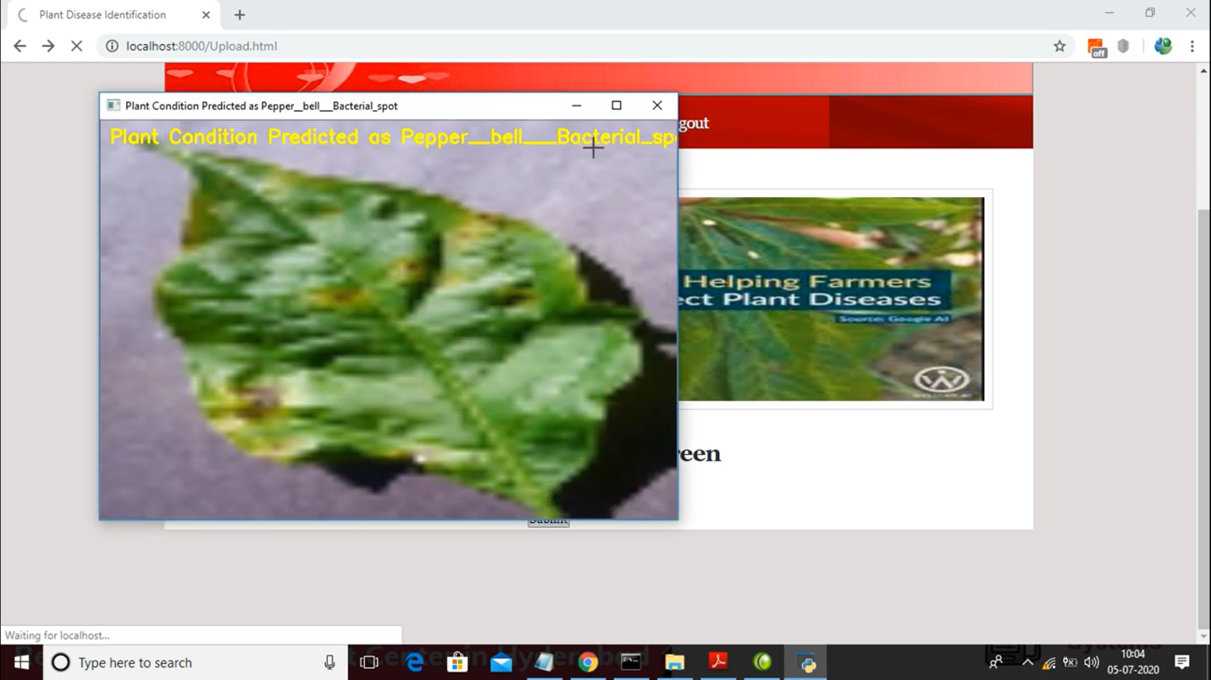

Figure 5.5 Result Disease identified and Pesticide recommended

The image appears to show a plant disease identification system at work. The interface indicates that the system has identified a condition in a leaf as "Pepper_bell_Bacterial_spot." The leaf displayed shows signs of discoloration, including brown or yellowish spots, which are typical symptoms of bacterial spot disease. This disease commonly affects pepper plants and is caused by Xanthomonas bacteria, which leads to the development of lesions on leaves, reducing the plant's ability to perform photosynthesis and potentially impacting crop yield. The system seems to be using machine learning to predict and label plant diseases, possibly aiding farmers in early detection and management.

6.TESTING

6.TESTING
6.1 INTRODUCTION TO TESTING
The purpose of testing is to discover errors. Testing is the process of trying to discover every conceivable fault or weakness in a work product. It provides a way to check the functionality of components, subassemblies, assemblies and/or a finished product. It is the process of exercising software with the intent of ensuring that the Software system meets its requirements and user expectations and does not fail in an unacceptable manner. There are various types of test. Each test type addresses a specific testing requirement.
6.2 TYPES OF TESTING
6.2.1 UNIT TESTING
Unit testing involves the design of test cases that validate that the internal program logic is functioning properly, and that program inputs produce valid outputs. All decision branches and internal code flow should be validated. It is the testing of individual software units of the application .it is done after the completion of an individual unit before integration. This is a structural testing, that relies on knowledge of its construction and is invasive. Unit tests perform basic tests at component level and test a specific business process, application, and/or system configuration. Unit tests ensure that each unique path of a business process performs accurately to the documented specifications and contains clearly defined inputs and expected results.
6.2.2 INTEGRATION TESTING
Integration tests are designed to test integrated software components to determine if they actually run as one program. Testing is event driven and is more concerned with the basic outcome of screens or fields. Integration tests demonstrate that although the components were individually satisfaction, as shown by successfully unit testing, the combination of components is correct and consistent. Integration testing is specifically aimed at exposing the problems that arise from the combination of components.

6.2.3 FUNCTIONAL TESTING
Functional tests provide systematic demonstrations that functions tested are available as specified by the business and technical requirements, system documentation, and user manuals.
Functional testing is centered on the following items:
Valid Input | : identified classes of valid input must be accepted.
Invalid Input | : identified classes of invalid input must be rejected.
Functions | : identified functions must be exercised.
Output | : identified classes of application outputs must be exercised.
Systems/Procedures: interfacing systems or procedures must be invoked.
Organization and preparation of functional tests is focused on requirements, key functions, or special test cases. In addition, systematic coverage pertaining to identify Business process flows; data fields, predefined processes.
6.3 TEST CASES
6.3.1 UPLOADING IMAGES
Test case ID | Test case name | Purpose | Test case | Output
1 | User uploads image | Use it foridentification | The user uploads a plant image | Uploaded  successfully
2 | User uploads 2nd image | Use it for identification | The user uploads the non plant image | Upload successfully

6.3.2 CLASSIFICATION
Test case ID | Test case name | Purpose | Input | Output
1 | Classification test 1 | To check if the classifier performs its task | A plant image is given | disease is predicted.
2 | Classification test 2 | To check if the classifier performs its task | A human image is given | It does not predicted as human.
3 | Classification test 3 | To check if the classifier performs its task | A object image is given | unpredicted

7. CONCLUSION

7.CONCLUSION AND FUTURE SCOPE
7.1 PROJECT CONCLUSION
A major issue in the agricultural arena is the need for early, accurate crop disease prognoses and information on disease outbreaks. In order to help farmers make quick judgements on what disorder management measures to use, this research suggests an automated, low-value, and person-friendly quit-to-stop solution to this problem. This concept introduces a social collaborative platform to gradually increase accuracy, uses geocoded pictures for sickness density maps, applies deep Convolutional Neural Networks (CNNs) to disease classification, and imparts a professional interface for analytics, among other ways it improves upon present work. "Inception" is a high-quality deep CNN model that enables the cloud-based, user-facing mobile app to provide real-time illness classification. The collaborative approach allows for the continuous enhancement of infection type accuracy by retraining the CNN version by automatically adding user-submitted images to the cloud-based education dataset. It is also possible to generate infection density maps using publicly accessible geolocation data within user-brought images stored in the cloud, in conjunction with existing data on collective illness classifications. In conclusion, our experimental results show that the proposal is practically deployable in a number of ways: it can detect early symptoms of diseases, differentiate between illnesses within the same family, perform better with high fidelity real-life training records, become more accurate as the training dataset grows, and run well on a cloud-based entirely infrastructure that could handle a huge variety of disease classes.
7.2 FUTURE SCOPE
In order to strengthen the connection to the pollution, future research should expand the model to include more variables. We may supplement the picture collection with farmer inputs about soil, previous applications of fertiliser and pesticides, and publicly available
environmental factors like temperature, humidity, and rainfall to improve our model's accuracy and enable disease predictions. We also want to decrease the frequency of expert engagement and broaden the spectrum of agricultural disorders
that may be managed, excluding newly discovered diseases. Finding the advantage is as simple as averaging the ranks for each category. More accurate class predictions with less human intervention will result from the ability to automatically normalise user-uploaded photos into the Training Database. This method may also be used to automate the monitoring and alerting of infection development utilising time-dependent disease density maps. With the use of predictive analytics, users may be alerted when disease outbreaks are possible in their own area.

8. BIBILOGRAPHY

8. BIBILOGRAPHY

8.1REFERENCES
